Agenda Fees!
Why weren’t agenda fees added to our regular fees in October?
After Bill 5 was brought in by the government regarding school fees, we were unable to add the cost of agendas directly into your annual school fees, instead having to make it an optional fee. Because of this we have had a low payment rate for agendas this year, leaving us with a large deficit.
Do our children need agendas?
As a staff, we feel that agenda use is a critical method for home/school communication and organization habits for students, so everyone was given an agenda at the start of the year. Over the past few years at School Council meeting feedback about agenda use was also widely supported.
What happens if we don’t receive a high level of agenda payment?
At our current payment rate, the purchase of agendas is unsustainable over time. At $3, the cost for agendas is very reasonable. The level of payment this year will impact our decision to purchase agendas in the future and take advantage of the high-volume purchase discount that the Division negotiated on behalf of schools.
What can we do to support the agenda program at the school?
We would ask that all parents please log into the Parent Portal to pay for their child’s agendas as soon as possible.
How do I purchase an agenda?
Follow these instructions:
- Log into the Parent Portal. Once logged in, select “Student Fees”.

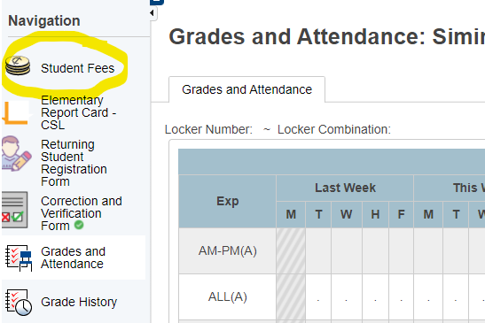

- Select your child’s name beside Summary. If you have more than one child who attends Woodbridge you will do this process twice.

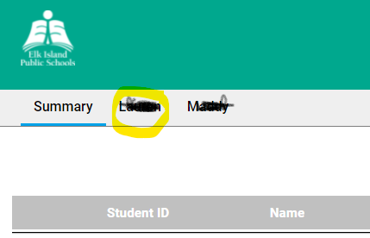

- At the bottom of the page, click on the “Agenda - $3.00” button.

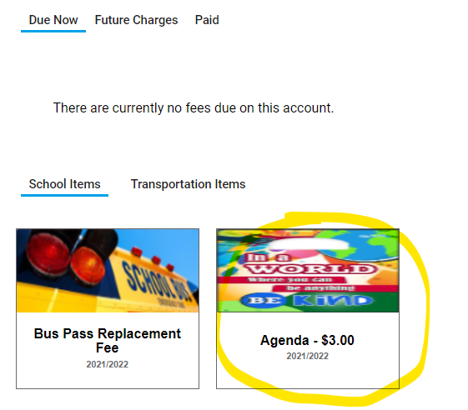

- Click “Add to Cart”.

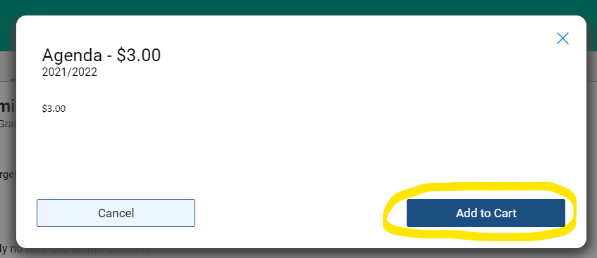

- Checkout and you’re done!

Thank you for your support!

